Global Challenge – H21
Due Wed, March 24, midnight (23:59)
5% late penalty per day from Thu, March 25 to Wed, March 31, midnight (23:59)
Not accepted Tue, March 31, midnight (23:59)
Read carefully before starting:
- Download this document in a safe place (i.e. server rather than desktop). Answer directly on this sheet below each question. When finished, submit your completed exam in BOTH Lea & Turnitin.
- Remember that Turnitin.com checks for similarity. Therefore, if your answers are identical, or even similar, to those of your classmates or to any Internet source, the system will detect it and you will get “0” for your exam as well as a letter in your Vanier file. Is it worth it? Further, if you try using my exact words from the PPts, I will notice! 😉
* Hence, all your answers must to be IN YOUR OWN WORDS.
- All the answers must refer to the class material and to no other sources since this is not a research work but an exam on the material covered.
- Answer the questions thoroughly and in as much depth as possible within the word limit indicated for each question. Be specific, accurate, provided details and present examples if applicable.
- Your goal in answering these questions is to show me, even convince me, that you diligently covered the course material and that you understand it. Hence, integrate concepts & keywords from the course in your answers.
* Answer only ONE of the choices provided. (If you answer all of them, I will only grade the 1st one.)
** Please highlight or bold your choice for every question **
/5 | - Short answers (~70 words). CHOOSE 1 among the following.  - How does my story about Tahiti represent an example of human disconnect with nature?  - What chapter of Reading C-9 does the Grameen bank fit in? Justify your answer.  - Of the 5 “Ps” of Sustainable Dev., what do “Partnership” & “Peace” refer to?  - How can Social and Solidarity Economy play a role in creating Sustainable Cities?  - What do Al Gore’ and Neomi Klein’s messages, from the trailers of their respective movies, have in common?  Your choice? ANSWER:  Partnership and peace refer creation of regional security in the participating states to promote global development. The comprehensive security concept is significant in conflict resolution and crisis management. The participating states would improve their relationship in a peaceful way that contributes to their agendas. A sense of lasting peace is influential in creating stability for most people living in various parts of the world. Strengthening of democratic institutions would get developed.
/5 | - Short answers (~70 words). CHOOSE 1 among the following.  - What initiatives can be undertaken to counteract the loss of biodiversity?  - Since “no water is leaving the planet”, what are water shortage issues about?  - Why is fragmentation problematic?  - How does the case of the ozone issue represent a “success story”?  - What do coral reefs and tropical rainforest have in common?  - What is eutrophication about?  Your choice? ANSWER:  Eutrophication refers to the enrichment of water by salt nutrients that cause changes ecosystem through increased algae production. The results of eutrophication deplete fish species in water after quality has got reduced. An increase in carbon dioxide and nutrient fertilizers leads to excessive growth of algal growth. Human activities like farming have led to eutrophication getting promoted in the aquatic systems. Deterioration of water quality leads to the formation of algae that prevents oxygen penetration.
/5  /5 | - Images to words  - CHOOSE 1 among the following images. Explain what point was made in my lecture about the image. (~70 words).  a) 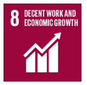 b) 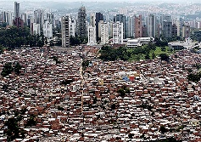 c) 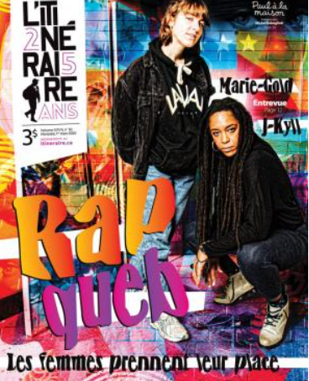 d) 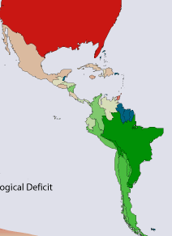  Your choice? ANSWER:  a)  Decent work and economic growth help in the transformation of societies for the better. It gets promoted by driving development that gets regarded as inclusive, equitable, and sustainable. Entrepreneurship gets introduced to help in promoting economic growth. Decent work assists in transforming societies through strengthening social protection to achieve global prosperity. Economic growth is essential in increasing the productivity of the country. It can get promoted through the creation of many job opportunities to ensure decent work gets achieved.  - CHOOSE 1 among the following sets of images. Explain the differences between the 2 images (~70 words).  a) 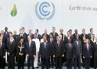 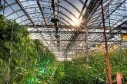 b)  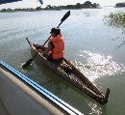 c)   Your choice? ANSWER:  a)  The first picture contains many people posing for a photo and seems to get done in an organization. People in official clothes who may have participated in a conference for their organizations exist in the picture. Contrarily, the second picture shows fodder in the greenhouse. The fodder has a gown and looks healthy because of its green nature. The second shows the random growth of the fodder without any arrangement.
/8 | - Interpreting quotes (~100 words). CHOOSE 1 among the following quotes from the course material and explain it in the light of the course.  - “So-called solutions risk only serve as band-aids, hence not really resolving the issues… Root causes?”  - About worldviews, “How we see the world determines how we act” (from video Western vs Indigenous views)  - “Chemical fertilization… Is it really necessary?”  - Economic growth: “Be patient… Wait until the cake gets just a little bigger… and then we’ll start sharing it out!  Your choice? ANSWER:  For successful economic growth to get achieved there is a need for people to get patient. The time taken to reach productivity by an organization would get long. Thus, people get urged to accept the process and work smartly without giving up. People should ensure that they increase their business performance and start enjoying it amongst themselves after reaching its peak. The challenges that get received while managing a business require motivation to work hard. The positive results of a business need to get shared after achieving productive success by all the members. Economic growth gets used in improving business performance.
/12 | - Making connections (~200 words). CHOOSE 1 among the following.  - Compare and contrast linear systems as described in the Story of Stuff video with cyclical processes of some of the nature’s ecosystem services involve. Discuss the differences between them highlighting the impacts of the latter on the environment.  - Explain how the early concept of Sustainable development with only 2 realms (economy and environment) can be associated with early nature conservation efforts. Then expand on how they both fell short in addressing the 3rd realm: social dimension.  - Compare the concepts of standards of living and quality of life in terms of their meaning, applications and impacts on the planet. Refer to concrete examples provided in the course.  Your choice? ANSWER:  Standard of living refers to the amount of wealth, material goods, and necessities available to a certain economic class. Standards of living can get categorized as rich and poor. Contrarily, quality of life is the measure of happiness that exists in the lives of people. People living without problems of accessing the basic needs tend to get happy at all times. Unhappy people face problems of accessing the basic needs that make their quality of life low. For instance, people living in slums tend to get unhappy at all times because of high poverty rates.  The application of standards of living concerns the lives that wealthy people achieve. For example, it gets shown by the lives of wealthy people who can buy anything they want. Wealthy people live high standards of lives that they want at any time. It gets applied in the lives of the wealthy people in the community. Conversely, quality of life can get applied through happiness that a person achieves in reaching their goals. The goals that get reached concern improvement of in achieving the basic needs. The impact of quality of life on the planet has led to people living by the common goal of fulfilling their needs.
/8 | - Case studies (~100 words). CHOOSE 1 among the following.  - In what way is the Denmark law an example of grassroots initiative?  - What is going in Cambodia and how is it related to poverty?  - What do the Grameen bank and Kiva have in common?  Your choice? ANSWER:  Cambodia has got many problems that have led to a reduction in its economic growth rate. First, Cambodia faces the challenge of basic social environment. There is a high rate of poverty in the country because of limited resources from its environment. Cambodia is a low-income country that faces the problem of a high poverty ratio amongst the citizens. The poor and needy ratio exceeds 30% of the population. The population growth rate is high that makes poverty cases get on the rise. The population of Cambodia gets increasing while poverty does not reduce. Low economic standards have championed poverty.
/48 /20
Enjoy showing off your acquired knowledge as
“knowledge is power!”
